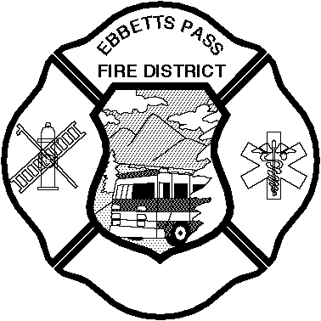

Ebbetts Pass Fire District

BOARD OF DIRECTORS

NOTICE OF REGULAR MEETING

**Via teleconference webinar**

**9:00 a.m. Tuesday, February 16, 2021**

**1037 Blagen Road, Arnold**

**In compliance with recently issued guidelines from the State of California and other governing agencies, and in order to aid in keeping the public safe, Ebbetts Pass Fire District (EPFD) will be conducting our Board Meeting via teleconference until further notice.**

**To access the meeting please visit zoom.us website and enter Meeting ID: 996 4083 9530 with password: 643037. If you need assistance in accessing this information, please email** [**epfd@epfd.org**](mailto:epfd@epfd.org) **or call the EPFD office at 209-795-1646, Monday through Friday, 8:00 am to 5:00 pm. You may also register in advance for this meeting:**

<https://zoom.us/j/99640839530?pwd=U09wamNyMWo5bHdXWDdhNWwwTnlEUT09>

**If you would like to comment on any item on our Agenda or an item not on the Agenda, please submit those in writing to our office at PO Box 66, 1037 Blagen Road, Arnold CA 95223 or via email at** [**epfd@epfd.org**](mailto:epfd@epfd.org) **at least 24 hours before the meeting. You may also submit comments via the “Chat” function available during the teleconference online.**

**MEMBERS OF THE BOARD**

**Denny Clemens, President Pete Neal, Secretary**

**Mike Barr Jon Dashner J. Scott McKinney**

**Concerning Public Comment**

Please Note:The Board of Directors offers the opportunity for the public to speak to specific agenda items during the time that agenda item is discussed by the Board. The Board also allows an opportunity for the public to speak on non‑agenda items during "public comments" prior to the conclusion of the meeting. The Board may not make any decision related to non-agendized items until the next Board meeting.

**AGENDA**

1. **Call to Order, Flag Salute, Roll Call**

2. **Public Appearances/Comment**: The Board will hear public comment on any agendized or

non‑agendized item. The Board may discuss public comment but may not take action.

3. **Consent Items**: Board action limited to discussion and approval of:

3.1. Minutes: 1/19/21

3.2. Acceptance of January 2021 Checks Listings and Authorize to File for Audit

4. **Committee Reports**: The Board will discuss the status of the following matters. The Board may take action on recommendations and/or give direction to staff or committee members related to follow-up on specific matters addressed by the committee.

4.1. **Finance Committee** (Directors Dashner & Barr)

4.2. **Personnel/Safety Committee** (Directors Dashner & McKinney)

4.3. **Fire Prevention Committee** (Directors Neal & Clemens)

4.4. **Apparatus/Equipment Committee** (Directors McKinney & Neal)

5. **Scheduled Items**: The Board will discuss and take action on the specific items listed below.

5.1. **NextDoor Posting:** Outstanding Fire Service – Marjorie Ramirez

5.2. Resolution 2021-1: Authorizing the Execution and Delivery of an Installment Sale Agreement, and Authorizing and Directing Certain Actions in Connection with the Acquisition of a Fire Truck

5.3. **California Special Districts Association:** Call For Nominations Seat A Board of Directors

5.4. **Calaveras Local Agency Formation Commission:** Extended Time Ballot for Independent Special District Representatives on LAFCO

5.5. **EPFD January 2021 Storms Cost Compilation**

5.6. **Ebbetts Pass Fire District Fire Ordinance 2020:**

5.6.1. Public Hearing

5.6.2. Adoption

6. **Reports**: The Board will hear reports on the following matters. The Board may discuss information contained in these reports.

6.1. Administrative Report

6.2. Legislative Report

6.3. Administrative – EMS

7. **Comments, Questions, and Consideration**: The Board will entertain comments and questions from the following individuals or representatives. The Board may discuss these comments or questions on these items but may not take action.

7.1. Board Members

7.2. Firefighters' Association

7.3. Employees' Group

7.4. Public Comments

8. **Adjournment of Regular Meeting**

**ADMINISTRATIVE STAFF:**

**Michael Johnson, Fire Chief**

**Cheryl Howard, Secretary**