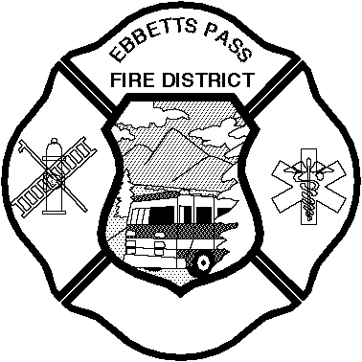

Ebbetts Pass Fire District

BOARD OF DIRECTORS

NOTICE OF REGULAR MEETING

**Via teleconference webinar**

**Tuesday, 9:00 a.m., June 16, 2020**

**In compliance with recently issued guidelines from the State of California and other governing agencies, and in order to aid in keeping the public safe, Ebbetts Pass Fire District (EPFD) will be conducting our Board Meeting via teleconference until further notice.**

**To access the meeting please visit zoom.us website and enter Meeting ID: 975-2563-4816 with password: 068405. If you need assistance in accessing this information, please email** [**epfd@epfd.org**](mailto:epfd@epfd.org) **or call the EPFD office at 209-795-1646, Monday through Friday, 8:00 am to 5:00 pm.**

**If you would like to comment on any item on our Agenda or an item not on the Agenda, please submit those in writing to our office at PO Box 66, 1037 Blagen Road, Arnold CA 95223 or via email at** [**epfd@epfd.org**](mailto:epfd@epfd.org) **at least 24 hours before the meeting. You may also submit comments via the “Chat” function available during the teleconference online.**

**MEMBERS OF THE BOARD**

**Mike Barr, President Denny Clemens, Secretary**

**Jon Dashner J. Scott McKinney Pete Neal**

**Concerning Public Comment**

Please Note:The Board of Directors offers the opportunity for the public to speak to specific agenda items during the time that agenda item is discussed by the Board. The Board also allows an opportunity for the public to speak on non‑agenda items during "public comments" prior to the conclusion of the meeting. The Board may not make any decision related to non-agendized items until the next Board meeting.

**AGENDA**

1. **Call to Order, Flag Salute, Roll Call**

2. **Public Appearances/Comment**: The Board will hear public comment on any agendized or

non‑agendized item. The Board may discuss public comment but may not take action.

3. **Consent Items**: Board action limited to discussion and approval of:

3.1. Minutes: 05/19/20

3.2. Acceptance of May 2020 Checks Listings and Authorize to File for Audit

4. **Committee Reports**: The Board will discuss the status of the following matters. The Board may take action on recommendations and/or give direction to staff or committee members related to follow-up on specific matters addressed by the committee.

4.1. **Finance Committee** (Directors Dashner & McKinney)

4.2. **Personnel/Safety Committee** (Directors Dashner & McKinney)

4.2.1. EPFD Practice regarding Domestic Partnership for medical benefits eligibility

4.2.2. End Probationary Period: Alex Baker

4.3. **Fire Prevention Committee** (Director Barr & Clemens).

4.4. **Apparatus/Equipment Committee** (Directors Clemens & Neal)

5. **Scheduled Items**: The Board will discuss and take action on the specific items listed below.

5.1. **2020 Biennial Conflict of Interest Code Review:** Review of current Conflict of Interest

5.1.1. Resolution No. 2020-6 Resolution Adopting a Conflict of Interest Code and Appendix of Designated Positions

5.2. **Resolution 2020-5:** Resolution Authorizing the Fire Chief to Sign Easement Deed and Associated Documents to Complete the PG&E Pre-installed Interconnection Hub Project on Fire District Property Located on Blagen Road in Arnold, CA

5.3. **Calaveras Health and Human Services Agency:** Calaveras County Moves Into Stage 3 Beginning Friday, June 12, 2020

5.4. **Annual District Signature Authorization for County Auditor-Controller:** Designation of EPFD District Person(s) Approved to Sign Claim Transmittals and Transfers

5.5. **Ebbetts Pass Fire Protection District Fire Ordinance 2020 Draft**: End of Prevention Committee Review- Possible Board approval to send in for legal review.

6. **Reports**: The Board will hear reports on the following matters. The Board may discuss information contained in these reports.

6.1. Administrative Report

6.2. Legislative Report

6.3. Administrative – EMS

7. **Comments, Questions, and Consideration**: The Board will entertain comments and questions from the following individuals or representatives. The Board may discuss these comments or questions on these items but may not take action.

7.1. Board Members

7.2. Firefighters' Association

7.3. Employees' Group

7.4. Public Comments

8. **Adjournment of Regular Meeting**

**ADMINISTRATIVE STAFF:**

**Michael Johnson, Fire Chief**

**Cheryl Howard, Secretary**